WEST LONDON WASTE AUTHORITY
Report of the Waste Minimisation Manager | 25 January 2019
Waste Minimisation Update

SUMMARY
This report provides an update on the Authority’s Waste Minimisation activities.

RECOMMENDATION(S)
The Authority is asked to:
Note the information within this report.

- Introduction – The Waste Minimisation Team delivers the campaigns that focus on minimising the seven key waste streams of food, textiles, waste electrical and electronic equipment, nappies, bulky household waste, plastics and dry mixed recycling. The team is also responsible for the Authority’s website, intranet, social media, and media communications.

- Key waste streams
  - Food Waste
    - 516 flats across seven sites in Richmond began a trial for food waste recycling collection for flats on the 20th of October. Working with managing agents of the sites, the Waste Minimisation team delivered letters, leaflets, caddy liners, indoor caddies and communal bins to residents around the Twickenham, Mortlake and Kew areas of the borough.
Collections have totalled at 2.04 tonnes since the project started 11 weeks ago. Current average weekly collection weight to date stands at 198.64kg which suggests an overall estimated household participation rate of 31%. There has been a gradual incline in collection weight with two peaks observed in December totalling of 380kg and 340kg, equating to active participations of 53-59%.
The aim of the pilot is to achieve 70% active participation with each property producing at least 1.25kg of food waste, totalling to 451.5kg per collection across the seven sites. The pilot is currently achieving approximately 63% of the final anticipated outcome. To boost the participation, the team will carry out further doorstepping, leafleting, distribution of liners, and various engagement activities in January-February 2019.

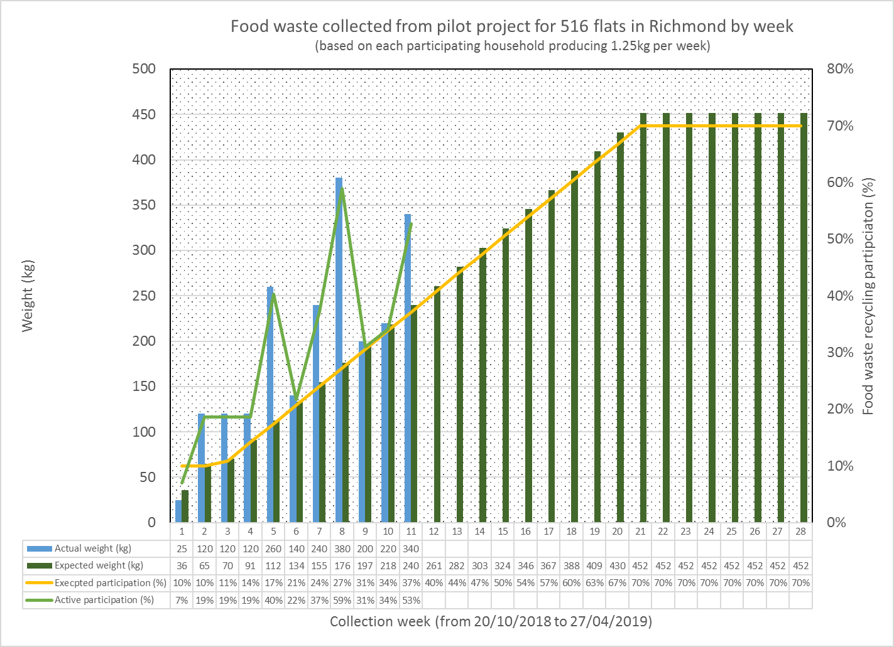
    - WLWA has put forward a proposal to assist Harrow Council with the significant roll-out of food waste recycling in approximately 14,000 flats between January and March 2019. The assistance will entail a round of doorstep intervention with distribution of leaflets for all properties following with a second phase of intervention addressing areas with low food waste recycling participation. Logistical arrangements and details are still to be confirmed by Harrow Council.
    - WLWA has agreed to lead on introducing food waste recycling at five housing estates in Hounslow. Those estates are currently undergoing a waste and recycling site improvement process before March 2019. Details of the sites and activities are yet to be confirmed by Hounslow Council.
    - A pilot for food waste recycling at school was setup at Krishna Avanti Primary School in Harrow. The school commenced its first collection on the 7th of December 2018. Activities for the pilot included carrying out comprehensive trainings for 20 school personnel including canteen staff and distribution of advisory and promotional communication (posters and receptacle stickers).
  - WEEE
    - A new kerbside WEEE collection trial covering 11,000 properties in Harrow, funded by DEFRA commenced in June 2018. The pilot ran weekly for six months to encourage diversion of electrical items from the general residual stream. The results are being analysed and a report will be available for the March Authority meeting.
    - The New Year WEEE collections are in progress with core venues including the Kiln Theatre, Richmond Civic Centre, Gayton Library and Chiswick Library confirmed. The collections will consist of an informational stand and a WEEE drop-off/recycling point.
  - Textiles
    - WLWA is working closely with Hounslow Council to implement five new public textile banks that will incorporate anti-social behaviour deterrents. Details of the sites and activities are yet to be confirmed by Hounslow Council.

    - On-request home collections operated by TRAID in Richmond has been seeing a gradual incline in the number of collection requests. Mirroring the trend, tonnage has also increased by 140% compared to data from 2017.
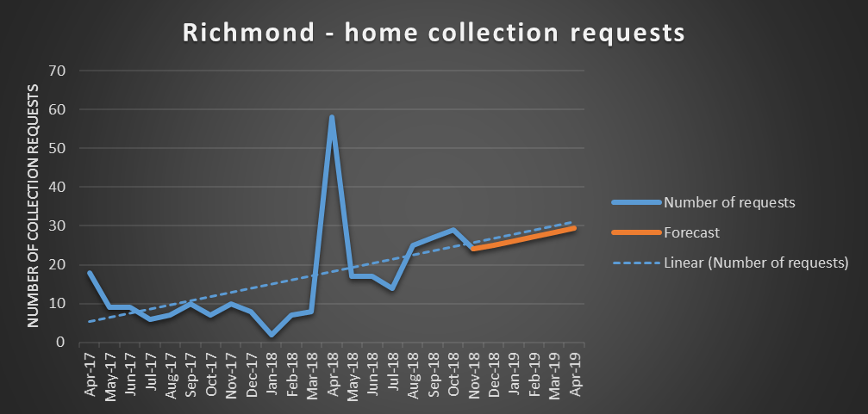
  - Reusable Nappies
    - The reusable nappies scheme saw an average of 12 incoming requests per month in 2018 compared to five for each month in 2017.
  - General;
    - The Waste Minimisation programme is on track.

Contact Officers | Mildred Jeakins, Waste Minimisation Manager  mildredjeakins@westlondonwaste.gov.uk | 01895 546 623
 | Emma Beal, Managing Director  emmabeal@westlondonwaste.gov.uk | 01895 545 515

